B502 – How to Check Reservation Details

View all details of a reservation, such as pick up and return information, customer name, BCD number, rate assigned, Fastbreak information, IATA number, billing information, special comments, booking source and time etc.

Searching for a Reservation by Confirmation Number

Enter QR or DR in the top left corner of the screen.

NAM: Enter ‘r/’ followed by the Confirmation Number of the reservation

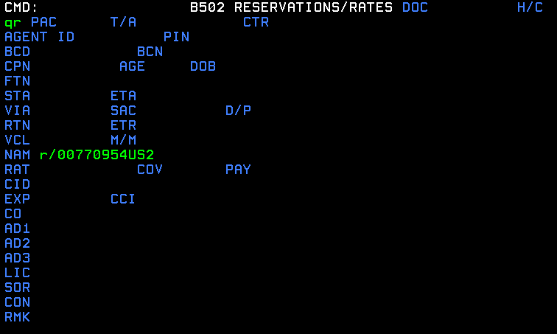

Press Enter to retrieve the reservation.

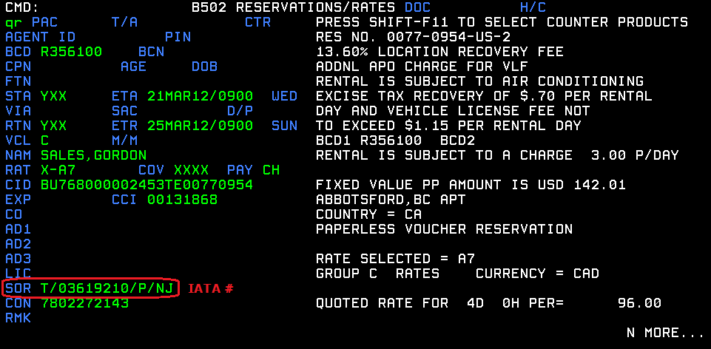
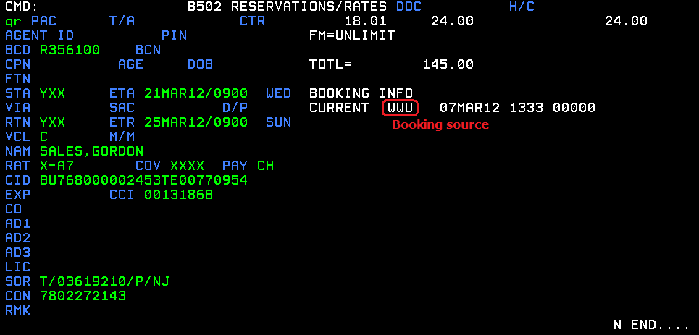
Searching for a Reservation by Customer Name and Pick Up Information

Enter QR in the top left corner of the screen.

STA: 4-digit Maestro station number or 3-letter mnemonic code
ETA: Date/Time (time is in 24hr format - e.g. 21MAR12/1300)
NAM: Last Name followed by a comma and First Name

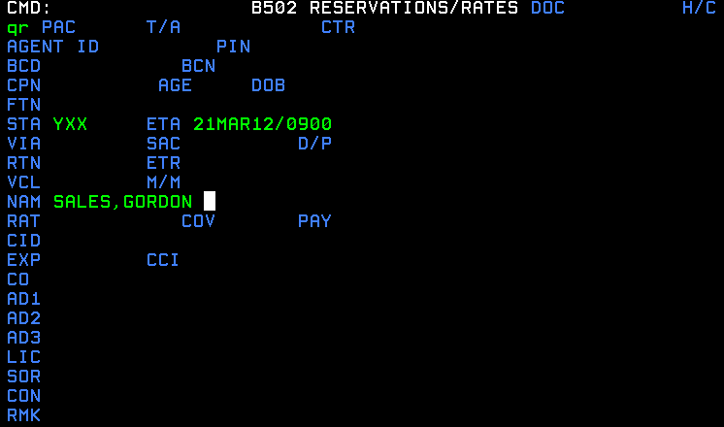

Press Enter to retrieve the reservation.

Note: For more detailed information about the IATA account or booking source, please refer to the IATA Name List.xls and Booking Source Codes.xls.

Tip:
1. The “N More...” at the bottom of the screen indicates more information pertaining to this reservation can be found. To advance to the next page, press the Page Up key.

2. The “N End….” At the bottom of the screen shows that you have reached the end of the page. To return to the main page, press Enter.

3. Press F9 beside a field to pull up a help menu which provides more information about a field.

